PLEASE MAKE A COPY OF THIS DOC AND ANSWER THE QUESTIONS ON YOUR COPY

Candidate: Taeyang, Kim

Date Sent: 2/18/2022

Date Returned: 2/23/2022

This take-home interview is a way for us to learn more about how you would respond to situations that regularly occur within the role and an opportunity for you to understand a snapshot of the work you would be performing on a daily basis. We recognize you don’t necessarily have all the data, people, and resources you’d expect to have access to in order to effectively tackle these scenarios. We’ll be looking at your responses for insight into your approach, especially the thought behind your work.

Please add your responses directly in the document and return them to kolby.dayley@vivint.com via email within 5 days of receipt. We understand that life happens, so if you anticipate a delay, please reach out.

Thank you,

Kolby Dayley

In developing your response to the first problem, the following observations might be useful:

* More than 80% of our traffic is mobile.
* Leads that submit forms convert about 10 percent (100 leads = 10 sales).
* Inbound leads (calls) convert about 30% (100 leads = 30 sales).

Problem #1

You are asked to increase sales from the website by increasing the form submission rate while also maintaining current call volume or by increasing the number of people who call into the call center from the home page of [vivint.com](https://www.vivint.com/). In looking at user recordings and looking at the data flow through the site, you put together the following 5 hypotheses and experiments to run:

1. **Hypothesis:** By changing the form CTA, we will change the way that the user interprets the form process and therefore make it easier for them to submit a form. 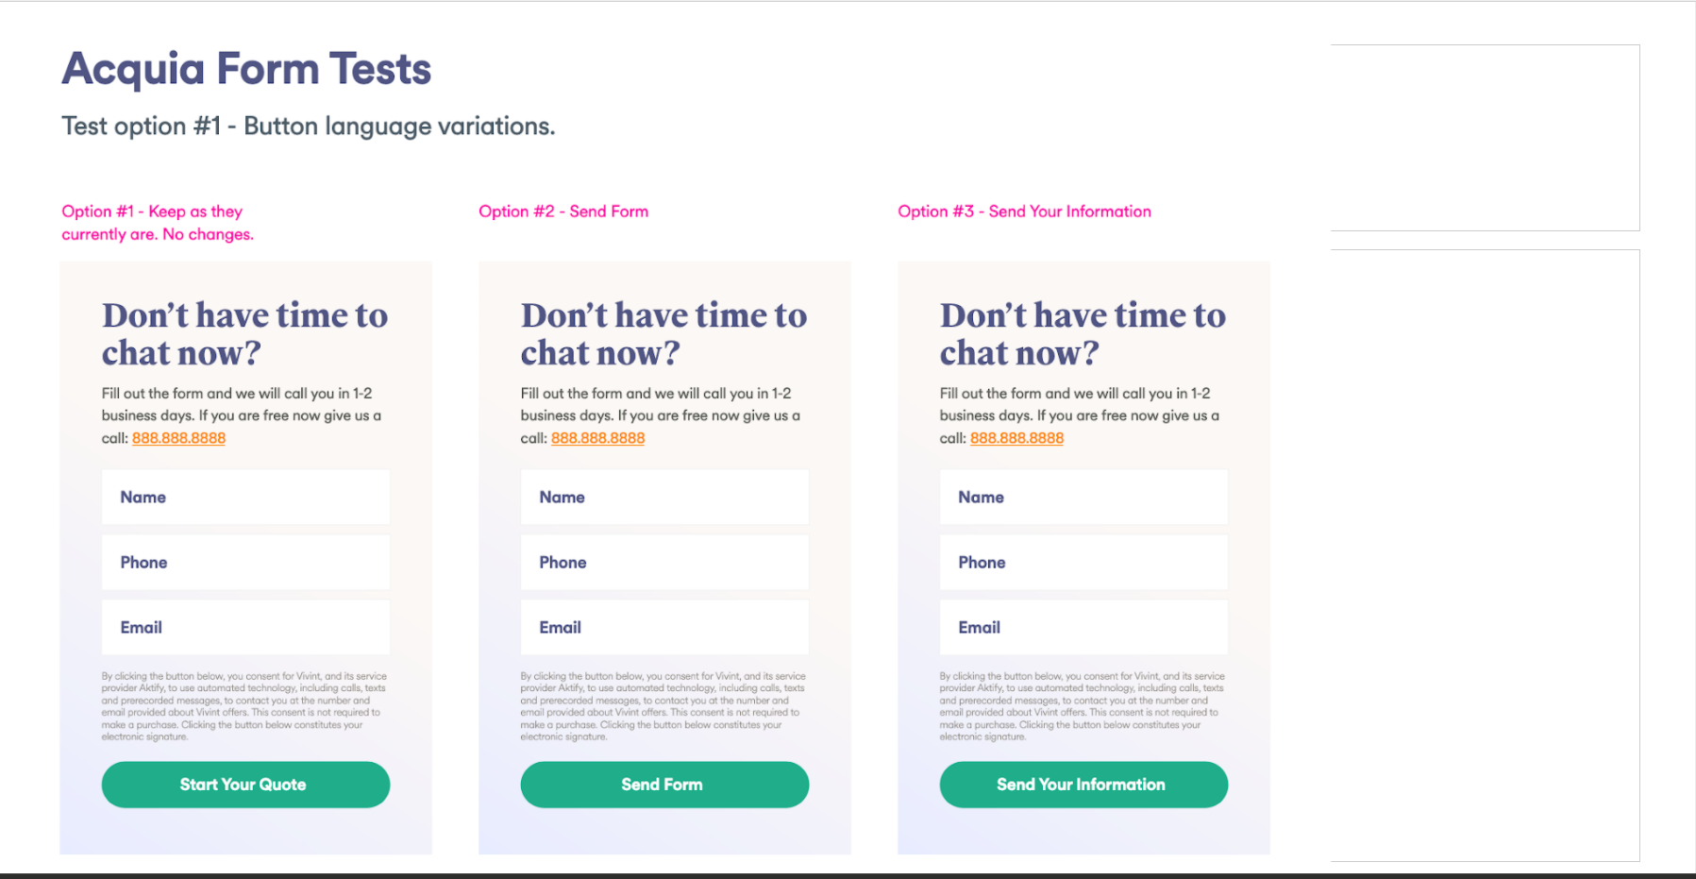
2. **Hypothesis:** By changing the color of the form CTA’s we will draw the proper level of attention to the form and therefore achieve a higher volume of people who notice and fill out the form.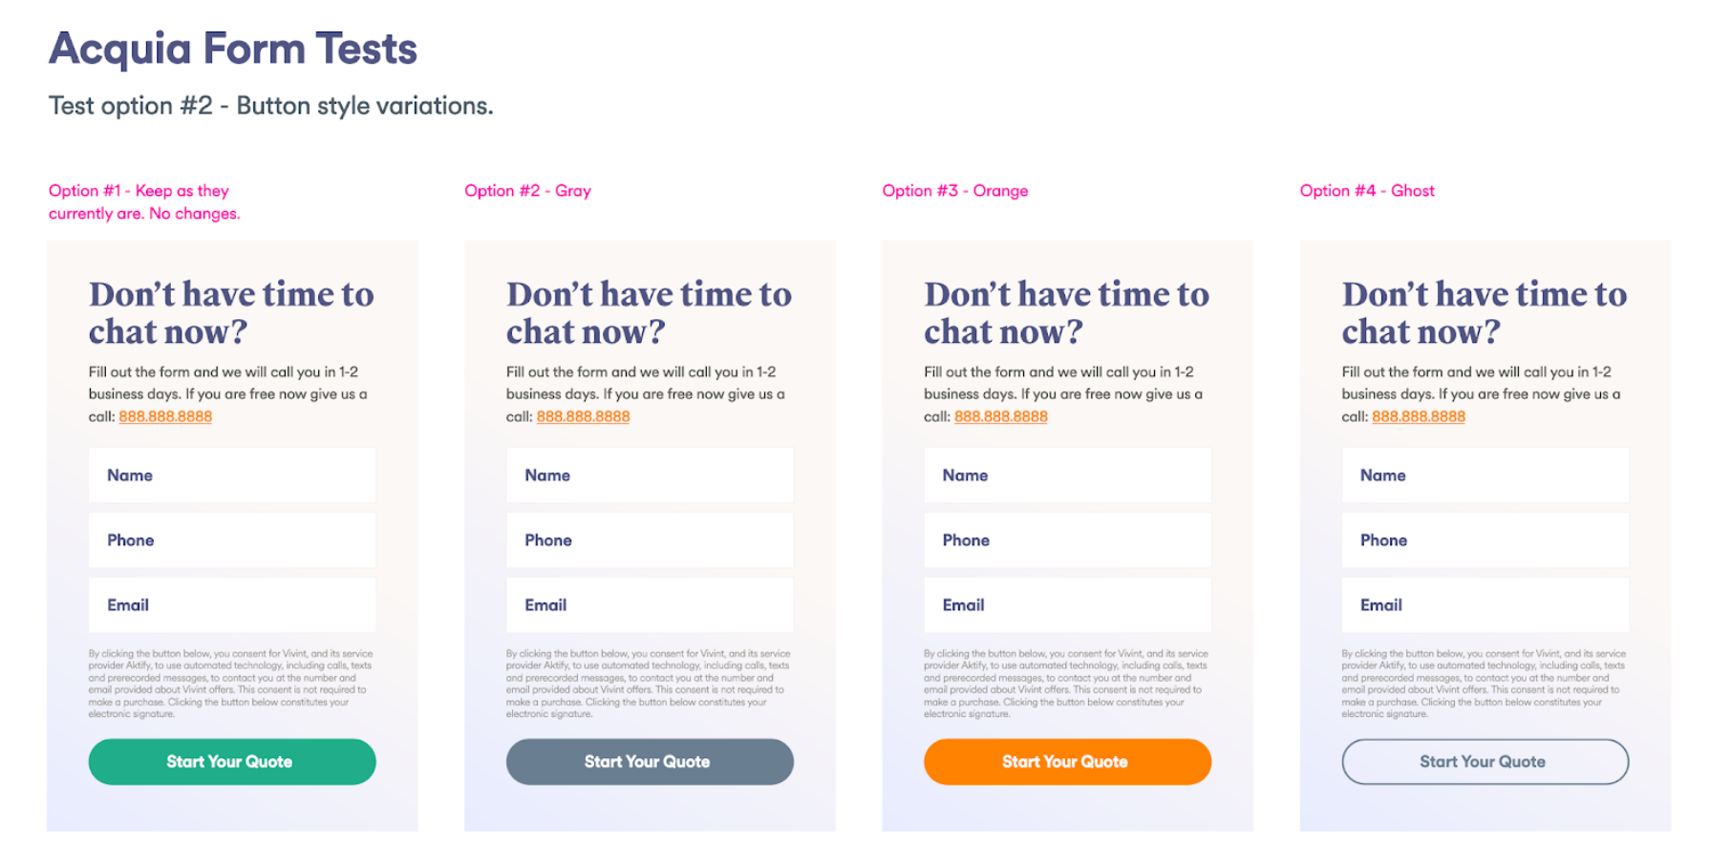
3. **Hypothesis:** By adding a call button under the form CTA, we will persuade people to call instead of filling out a form and therefore gain a higher number of overall sales. 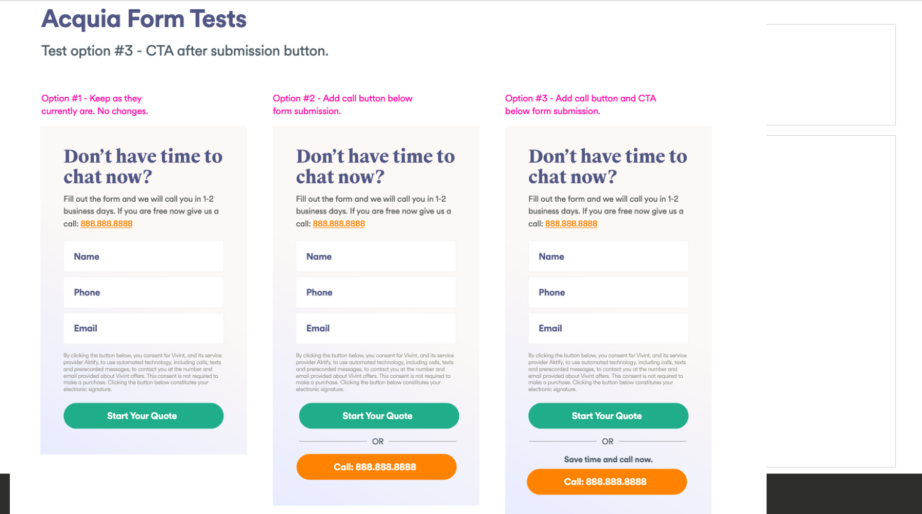
4. **Hypothesis:** By even more emphasis on the call button and placing it in the context of the form, we will persuade people to call instead of filling out a form and therefore gain a higher number of overall sales. 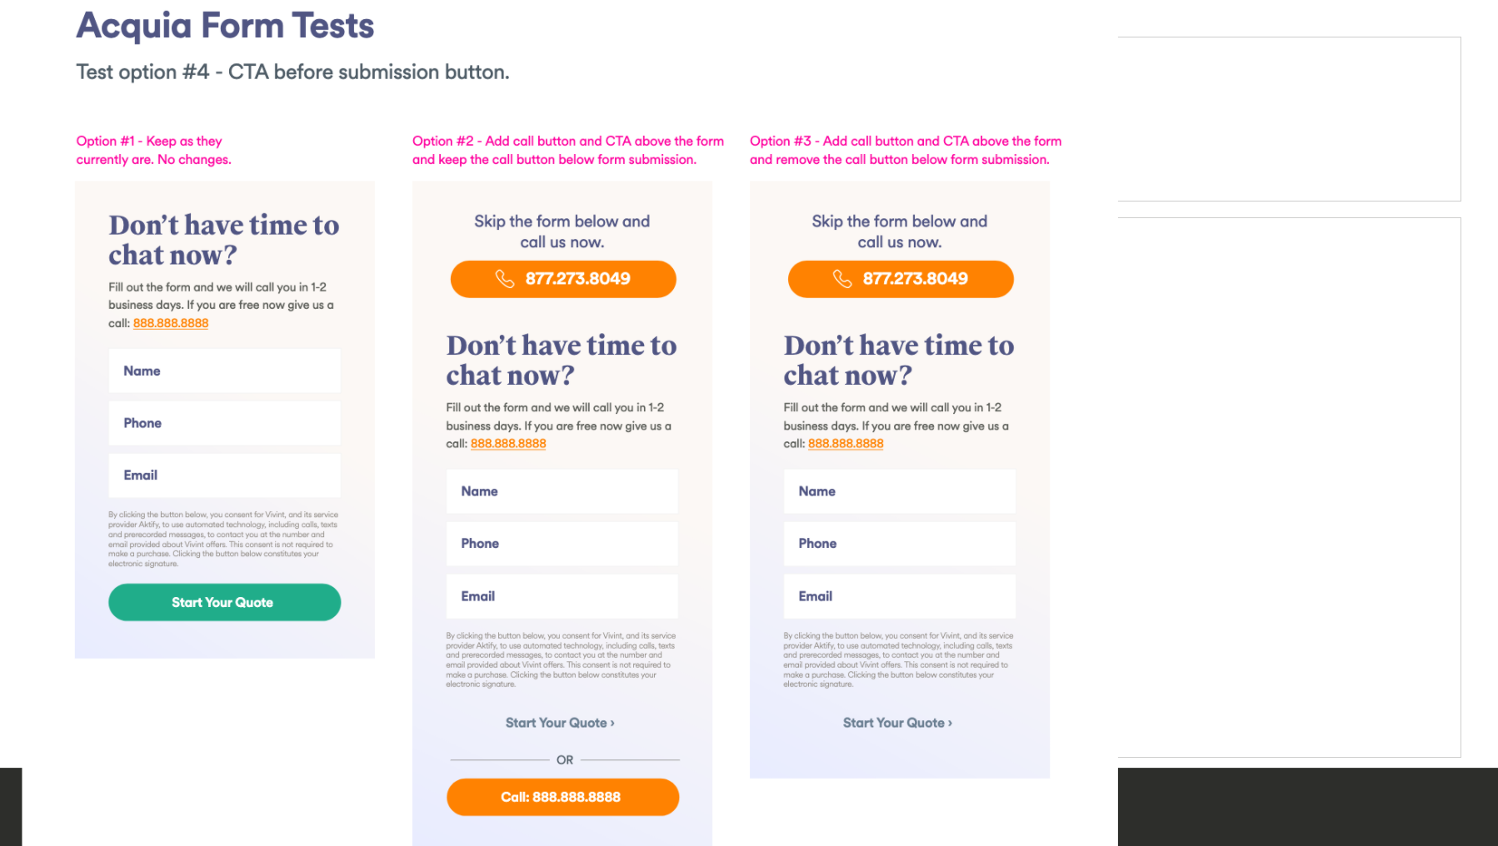
5. **Hypothesis:** By simplifying the form, we will promote calling in, while still allowing those who are looking for the form to be able to find it and therefore have more people call in, resulting in more sales. 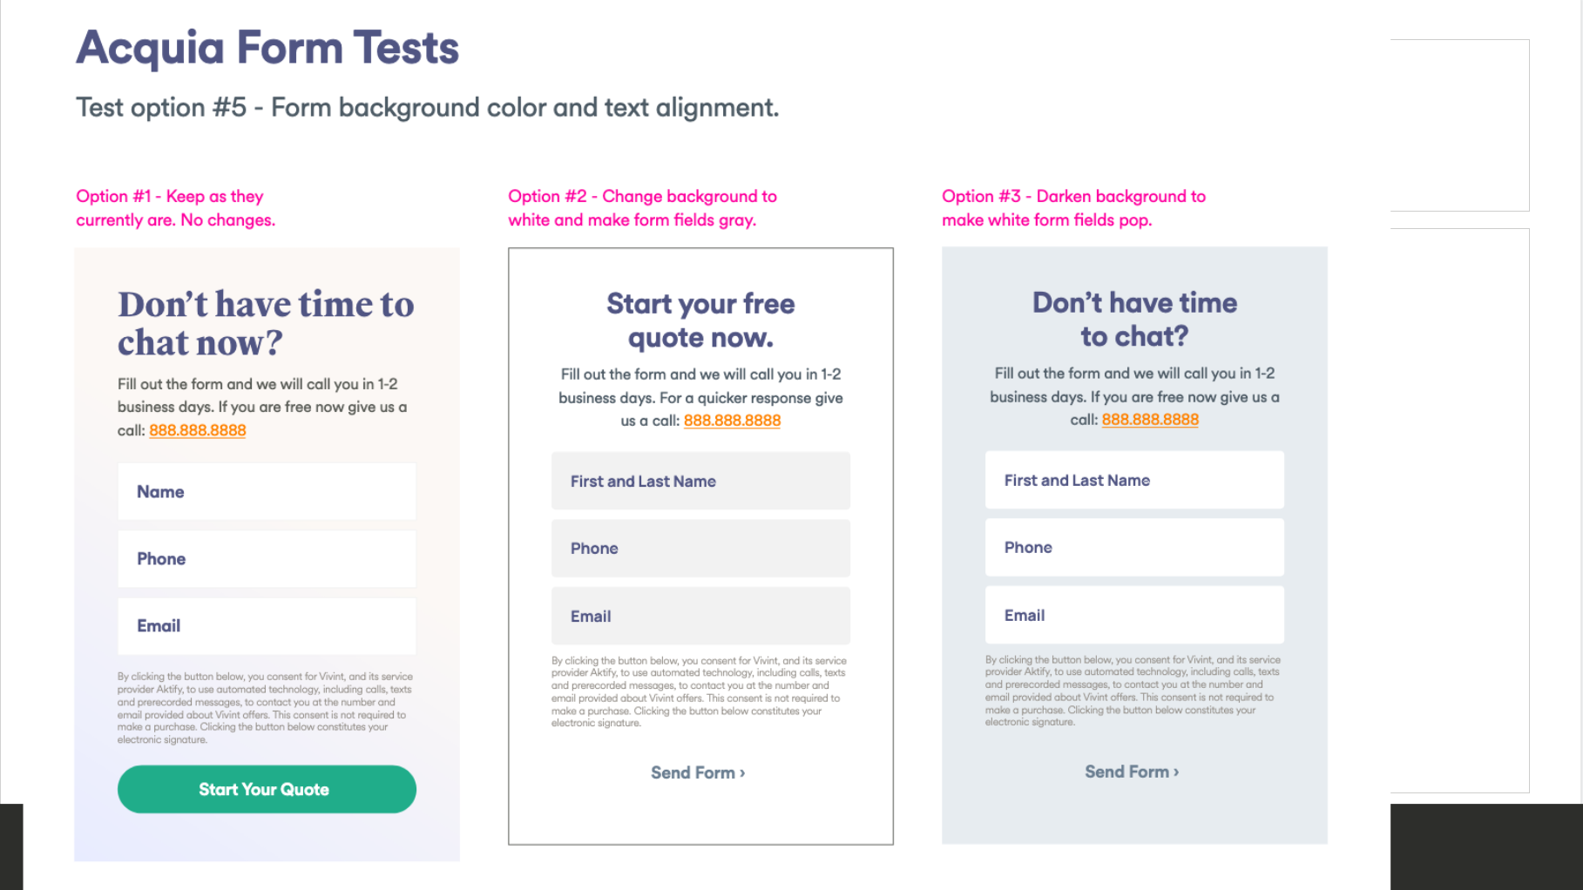

**Question:**

How would you prioritize these five tests? In what order would you test these concepts? Explain your reasoning behind the placement of each test.

What other ideas might you offer?

**Answer:**

Our ultimate goal is to increase the sale. To achieve the goal, an immediate phone call is the best approach, receiving responses from users is the second, and no response is the least desired result. By setting the priority with that order, I would prioritize the given hypotheses in this order: 4, 3, 5, 1, 2.

The first test is hypothesis 4. The reason why I chose this hypothesis is that it strongly motivates the call instead of submitting the form. I liked how it persuades users to choose to call instead of going through tedious steps of submitting the form. So, I prioritized the phone calls more than submitting the form.

The second test is hypothesis 3. I liked how it gently motivates users to decide between two choices. This test will help Vivint to know how users behave when they are given two choices. So, I placed this in the second.

The reason behind choosing hypothesis 5 third is that I’d like to check if the form button really matters. This hypothesis minimized the button part so that it might lead users to more phone calls. If users don’t pay much attention, they will feel that the only option for contacting Vivint is through a phone call. This is the reason why this hypothesis could be risky, but it’s still worth testing.

The fourth test I prioritized is to test hypothesis 1. I believe that it’s first important to check the wording to see what the best phrase is before changing the color of the button. If it matters to increase sales quickly, I will prioritize hypothesis 2 over 1 because I believe that changing the color can affect click rates more greatly. However, I think that the right order is to test the wording and then the color.

The last test I set is changing the color of the button because I prioritized the goal of phone call over the submitting the form. If I prioritized only the clicking rates, then I would have completely changed the priority of these hypotheses. However, I believe that doing the test for meeting the goal is more important than just making the website look nice.

Another Idea for Vivint Website to increase the participation rates is to create the page for “Find My Right Vivint Plan” for the customer.

The purpose of the “Find My Right Vivint Plan” webpage is to suggest customized plans for potential customers and increase sales. This webpage asks questions such as “How many IoT devices do you have?” “How many rooms do you have?” “What is the most concern that you have in your home?” and “How much money do you want to spend for each month?” These questions can lead to valuable data.

Additionally, this webpage could suggest customized plans for users to buy or contract. The benefit of this webpage is that Vivint can earn valuable potential customers’ data, and it has a higher possibility for users to actually buy the plan since it’s customized. This webpage can be used in other marketing platforms such as Facebook, Instagram, and YouTube. For instance, Vivint can make a post with a phrase such as “Find My Right IoT Home Plan for Free” in Instagram. This kind of post is far better than an advertising post with sales information because it’s more customized to the potential customers.

I hope to develop this website and test it for Vivint. I hope to participate other ongoing marketing projects of Vivint as well. 😊

Problem #2

Code a new component onto [Vivint.com](https://www.vivint.com/), under the hero image, using your browser console. The new component is to be a countdown timer which shows a countdown to the end of the day (11:59 PM) in mountain standard time using only vanilla JavaScript (no JQuery or other libraries). This is to be responsive down to a 360px screen width. Copy and paste your JavaScript and CSS into this document ready for me to add it to my own browser’s console to test. Please reach out with any questions that you have or if you get stuck. Please design your component to match the countdown timer in the screenshots below as closely as possible–ignore the hero image as this may be different when you view the site. Please use your own code. If you have a question or get stuck, you can reach out to me and I can send you over a resource that can help you, there is no shame in not knowing, I am a heavy stack-overflow subscriber myself. This, however, is so that I can get to know your coding skill.

<script.js>

/**Setting Head of HTML*/

function setHeadHTML() {

    const responsiveSetting = document.createElement('meta');

    responsiveSetting.name = "viewport";

    responsiveSetting.content = "width=device-width, initial-scale=1.0";

    const styleLink = document.createElement('link');

    styleLink.rel = "stylesheet";

    styleLink.href = "./styles.css";

    const title = document.createElement('title');

    title.innerHTML = "Vivint";

    document.head.appendChild(responsiveSetting);

    document.head.appendChild(styleLink);

    document.head.appendChild(title);

}

var countDownTime = {

    time: [25, 5, 00, 20],/**order: days, hours, minutes, seconds */

    valid: false,/**valid if the coundDownTime is bigger than current time */

    done: false /**done if the coundDownTime set to 0 */

}

/**Time Function */

function checkCountDown(currentTime) {

    for (let i = 0; i < 4; i++) {

        if (countDownTime.time[i] < currentTime[i]) {

            return false;

        }

        else if (countDownTime.time[i] > currentTime[i]) {

            return true;

        }

        else {

            continue;

        }

    }

    return false;

}

function calculate60(subtractTime, index) {

    if (countDownTime.time[index] < subtractTime) {

        countDownTime.time[index] = countDownTime.time[index] + 60 - subtractTime;

        countDownTime.time[index - 1]--;

    }

    else {

        countDownTime.time[index] -= subtractTime;

    }

}

function calculateHours(subtractTime) {

    if (countDownTime.time[1] < subtractTime) {

        countDownTime.time[1] = countDownTime.time[1] + 24 - subtractTime;

        countDownTime.time[0]--;

    }

    else {

        countDownTime.time[1] -= subtractTime;

    }

}

function calculateDays(subtractTime) {

    countDownTime.time[0] -= subtractTime;

}

function timeCalculator(subtractTime) {

    valid = checkCountDown(subtractTime);

    if (valid) {

        /**Second */

        calculate60(subtractTime[3], 3);

        /**Minute */

        calculate60(subtractTime[2], 2);

        /**Hour */

        calculateHours(subtractTime[1]);

        /**Day */

        calculateDays(subtractTime[0]);

    }

}

function settingCountDownTime() {

    var currentTime = new Date();

    var subtractTime = [currentTime.getDate(), currentTime.getHours(), currentTime.getMinutes(), currentTime.getSeconds()];

    timeCalculator(subtractTime);

}

function getClassData(className, index) {

    return document.getElementsByClassName(className)[index].firstChild.innerHTML;

}

function changeSecond() {

    var second = parseInt(getClassData("time-box", 3));

    if (second === 0) {

        if (!changeMinute()) {

            return false;

        }

        second = 59;

    }

    else {

        second--;

    }

    document.getElementsByClassName("time-box")[3].firstChild.innerHTML = second;

    return true;

}

function changeMinute() {

    var minute = parseInt(getClassData("time-box", 2));

    if (minute === 0) {

        if (!changeHour()) {

            return false;

        }

        minute = 59;

    }

    else {

        minute--;

    }

    document.getElementsByClassName("time-box")[2].firstChild.innerHTML = minute;

    return true;

}

function changeHour() {

    var hour = parseInt(getClassData("time-box", 1));

    if (hour === 0) {

        if (!changeDay()) {

            return false;

        }

        hour = 23;

    }

    else {

        hour--;

    }

    document.getElementsByClassName("time-box")[1].firstChild.innerHTML = hour;

    return true;

}

function changeDay() {

    var day = parseInt(getClassData("time-box", 0));

    if (day === 0) {

        return false;

    }

    else {

        day--;

    }

    document.getElementsByClassName("time-box")[0].firstChild.innerHTML = day;

    return true;

}

function remove(parent) {

    while (parent.firstChild) {

        parent.removeChild(parent.firstChild);

    }

}

/**Time change */

function countDown() {

    countDownTime.done = changeSecond();

    if (!countDownTime.done) {

        remove(document.getElementsByClassName("banner")[0]);

        var element = document.getElementsByClassName("banner")[0];

        element.parentNode.removeChild(element);

        clearInterval(countInterval);

    }

}

/**Header Helping Functions */

function createDiv(className) {

    const newDiv = document.createElement('div');

    newDiv.className = className;

    return newDiv;

}

function createDivWithText(className, textInfo) {

    const newDiv = createDiv(className);

    newDiv.innerHTML = textInfo;

    return newDiv;

}

function createImageLink(url, imgPath, className) {

    const link = document.createElement('a');

    const img = document.createElement('img');

    link.href = url;

    img.src = imgPath;

    img.className = className;

    link.appendChild(img);

    return link;

}

function createSpan(message) {

    const span = document.createElement('span');

    span.innerHTML = message;

    return span;

}

function createP(message) {

    const p = document.createElement('p');

    p.innerHTML = message;

    return p;

}

/**Main Message Helping Functions */

function createClickButton() {

    const button = document.createElement('a');

    const img = document.createElement('img');

    const span = createSpan("877.537.3785");

    button.href = "tel:18775373785";

    button.className = "button";

    img.src = "https://www.iconsdb.com/icons/preview/white/phone-xxl.png";

    img.className = "icon";

    button.appendChild(img);

    button.appendChild(span);

    return button;

}

function createExtraText() {

    const extra_text = createDiv("extra-text");

    extra_text.innerHTML = "*With qualifiying system purchase.&nbsp;";

    const link = document.createElement('a');

    link.href = "https://www.vivint.com/#hero-promo-details";

    link.innerHTML = "Offer details";

    extra_text.appendChild(link);

    return extra_text;

}

/**Banner Helping Function */

function createTimeBox(time_type) {

    const time_box = createDiv("time-box");

    const span_message = createSpan(time_type);

    const p = createP('');

    switch (time_type) {

        case "days":

            p.innerHTML = countDownTime.time[0];

            break;

        case "hours":

            p.innerHTML = countDownTime.time[1];

            break;

        case "minutes":

            p.innerHTML = countDownTime.time[2];

            break;

        default:

            p.innerHTML = countDownTime.time[3];

            break;

    }

    time_box.appendChild(p);

    time_box.appendChild(span_message);

    return time_box;

}

function createTimer() {

    const timer = createDiv("timer");

    const days = createTimeBox("days");

    const hours = createTimeBox("hours");

    const minutes = createTimeBox("minutes");

    const seconds = createTimeBox("seconds");

    timer.appendChild(days);

    timer.appendChild(hours);

    timer.appendChild(minutes);

    timer.appendChild(seconds);

    return timer;

}

/**Create Header */

function createHeader() {

    const header = createDiv("header");

    const logoLink = createImageLink("https://www.vivint.com/", "https://postfiles.pstatic.net/MjAyMjAyMjJfMjk3/MDAxNjQ1NDg1NzExMDk0.ZNCWcaEniMlVcUH-Iah1UhenPl0qCfSgGUes7OtzCpUg.-RKWgpd-Av4oTl9v8OREMhePivwoxfDs7JAXaM4-nXMg.PNG.upiioo/vivint_logo.PNG?type=w966", "logo");

    header.appendChild(logoLink);

    document.body.appendChild(header);

}

/*ContentWrapper Functions*/

function createMainMessage() {

    const content_wrapper = createDiv("content-wrapper");

    const content = createDiv("content");

    const small_text_1 = createDivWithText("small-text", "HOME SECURITY SALE");

    const big_text = createDivWithText("big-text", "Up to 4 Months FREE<br>Monitoring + FREE<br>Installation*<br></br>");

    const small_text_2 = createDivWithText("small-text", "CALL NOW: USE PROMO CODE 4FREE");

    const button = createClickButton();

    const extra_text = createExtraText();

    const empty = createDiv("empty");

    content.appendChild(small_text_1);

    content.appendChild(big_text);

    content.appendChild(small_text_2);

    content.appendChild(button);

    content.appendChild(extra_text);

    content_wrapper.appendChild(content);

    content_wrapper.appendChild(empty);

    document.body.appendChild(content_wrapper);

}

/* Banner*/

function createTimeBanner() {

    const banner = document.createElement('a');

    banner.href = "https://www.vivint.com/packages/home-security";

    /**This link can be changed to desired url */

    banner.className = "banner";

    const text_box = createDivWithText("text-box", "Get Offer Before Close");

    const timer = createTimer();

    banner.appendChild(text_box);

    banner.appendChild(timer);

    document.body.appendChild(banner);

}

/* Every Functions for Landing Webpage*/

setHeadHTML();

createHeader();

createMainMessage();

settingCountDownTime();

if (valid) {

    createTimeBanner();

    var countInterval = setInterval(function () {

        countDown();

    }, 1000);

}

<styles.css>

* {

    margin: 0;

    padding: 0;

}

.body {

    margin: 0;

    padding: 0;

    font-family: Helvetica;

    font-weight: 400;

    line-height: 1.5;

    -webkit-font-smoothing: antialiased;

    width: 100%;

}

.header {

    margin: 0;

    height: 5em;

    width: 100%;

    display: flex;

    align-items: center;

    justify-content: center;

    background-color: #141c1c;

    position: fixed;

}

.logo {

    height: 5em;

}

.content-wrapper {

    padding: 0;

    background-image: url(https://cdn.optimizely.com/img/12265111463/d81bc52566104ee287079fa3659b1a2a.jpg);

    background-position: center;

    background-repeat: no-repeat;

    background-size: cover;

    height: 700px;

    margin-bottom: 6em;

    object-fit: scale-down;

    display: flex;

    align-items: center;

    justify-content: center;

}

.content {

    display: flex;

    flex-direction: column;

    align-items: left;

    text-align: left;

    flex: 2;

    padding: 12em 0em 8em 8em;

    color: #fff;

}

.empty {

    display: flex;

    flex: 3;

    align-items: center;

}

.icon {

    width: 1em;

    height: 1.2em;

    padding-left: 0;

    padding-right: 1em;

}

.button {

    display: flex;

    justify-content: center;

    width: 12.2em;

    padding: 20px 0px;

    border-radius: 40px;

    background-color: #00c59b;

    margin-bottom: 1em;

    color: #fff;

    text-decoration: none;

    font-size: 1.6em;

    font-weight: bold;

}

.button img {

    size: 2em;

}

.button:hover {

    background-color: #00daaa;

}

.call-icon {

    flex: 1;

}

.button-text {

    flex: 4;

}

.big-text {

    font-size: 2em;

    margin-bottom: 1.7em;

    font-weight: bold;

}

.small-text {

    font-size: 0.7em;

    margin-bottom: 1em;

    letter-spacing: 0.2em;

}

.extra-text {

    display: flex;

    font-size: 4px;

    letter-spacing: 0.2em;

}

.big-text, .small-text, .extra-text>a {

    color: #fff;

}

.banner {

    display: flex;

    position: fixed;

    text-decoration: none;

    bottom: 0;

    width: 100%;

    justify-content: center;

    align-items: center;

    height: 5em;

    background-color: #80332e;

    margin-bottom: 0;

}

.text-box {

    padding: 1em;

    font-size: 1.5em;

    color: #fff;

}

.timer {

    display: flex;

    justify-content: center;

}

.time-box {

    display: flex;

    width: 4em;

    height: 4em;

    border-radius: 5px;

    margin: 0.5em;

    justify-content: center;

    align-items: center;

    flex-direction: column;

    color: #000;

    background-color: #fff;

    flex-wrap: nowrap;

    line-height: 1.3em;

    font-weight: bold;

}

.time-box p {

    padding-top: 0.4em;

    font-size: 1.6em;

}

.time-box span {

    font-size: 0.8em;

    color: #505050;

}

@media only screen and (max-width:360px) {

    .header {

        height: 4.5em;

    }

    .logo {

        height: 4.5em;

    }

    .content-wrapper {

        background-image: url(https://cdn.optimizely.com/img/12265111463/a59dc44d7000439d95d7ddf3f072ff90.jpg);

        background-size:cover 700px;

        flex-direction: column;

        width: 100%;

        margin-bottom: 6em;

        /*change a height, flex-direction*/

    }

    .content {

        width: 100%;

        padding: 7em 0 0 0;

        align-items: center;

    }

    .small-text {

        align-items: center;

        font-size: 0.5em;

    }

    .big-text {

        align-items: center;

        text-align: center;

        font-size: 1.6em;

        font-weight: 400;

        margin-bottom: 1.3em;

    }

    .button {

        width: 10em;

    }

    .icon {

        width: 1em;

        height: 1em;

        position: relative;

        left: 12px;

        top: 6px;

    }

    .extra-text {

        flex-direction: column;

        align-items: center;

    }

    .empty {

        flex: 0;

        width: 0;

        height: 0;

    }

    .banner {

        display: flex;

        flex-direction: column;

        justify-content: center;

        align-items: center;

        height: 9em;

        background-color: #80332e;

        margin-bottom: 0;

        line-height: 0em;

    }

    .text-box {

        padding: 0.4em 0 1em 0;

        font-size: 1em;

        color: #fff;

    }

    .timer {

        display: flex;

        justify-content: center;

    }

    .time-box {

        display: flex;

        width: 4em;

        height: 4em;

        border-radius: 5px;

        margin: 0.22em;

        justify-content: center;

        align-items: center;

        flex-direction: column;

        background-color: #fff;

        flex-wrap: nowrap;

        line-height: 1.3em;

    }

    .time-box p {

        padding-top: 0.4em;

        font-size: 1.6em;

        font-weight: bold;

    }

    .time-box span {

        font-size: 0.9em;

    }

}

@media only screen and (min-width:361px) and (max-width:767px) {

    .header {

        height: 4.5em;

    }

    .logo {

        height: 4.5em;

    }

    .content-wrapper {

        background-image: url(https://cdn.optimizely.com/img/12265111463/b2e16202c5d749f996fd6ef186f9ea8f.jpg);

        background-size: cover 600px;

    }

    .content {

        padding: 4em 0em 8em 1.5em;

        color: #fff;

    }

    .empty {

        flex: 0;

    }

    .button {

        width: 10.2em;

        padding: 20px 20px;

        border-radius: 40px;

        margin-bottom: 1.4em;

        color: #fff;

        font-size: 1.2em;

    }

    .big-text {

        font-size: 1.9em;

        margin-bottom: 1em;

    }

    .small-text {

        font-size: 0.7em;

        margin-bottom: 1.5em;

        letter-spacing: 0.2em;

    }

    .extra-text {

        font-size: 1px;

        letter-spacing: 0.2em;

    }

    .banner {

        display: flex;

        flex-direction: column;

        justify-content: center;

        align-items: center;

        height: 9em;

        background-color: #80332e;

        margin-bottom: 0;

        line-height: 0em;

    }

    .text-box {

        padding: 0.7em 0 0.6em 0;

        font-size: 1.2em;

        color: #fff;

    }

    .timer {

        display: flex;

        justify-content: center;

    }

    .time-box {

        display: flex;

        width: 4em;

        height: 4em;

        border-radius: 5px;

        margin: 0.5em;

        justify-content: center;

        align-items: center;

        flex-direction: column;

        background-color: #fff;

        flex-wrap: nowrap;

        line-height: 1.3em;

    }

    .time-box p {

        padding-top: 0.4em;

        font-size: 1.6em;

        font-weight: bold;

    }

    .time-box span {

        font-size: 0.5em;

    }

}

@media only screen and (min-width:768px) and (max-width:1200px) {

    .content {

        display: flex;

        flex-direction: column;

        align-items: left;

        text-align: left;

        flex: 2;

        padding: 8em 0em 8em 4em;

        color: #fff;

    }

    .big-text {

        font-size: 1.8em;

    }

}

